THE MINISTRY OF EDUCATION AND SCIENCE OF UKRAINE
ODESA I. I. MECHNIKOV NATIONAL UNIVERSITY
THE COUNCIL OF BOTANICAL GARDENS AND ARBORETUMS OF UKRAINE
V. I. LIPSKY BOTANICAL GARDEN OF
ODESA I. I. MECHNIKOV NATIONAL UNIVERSITY
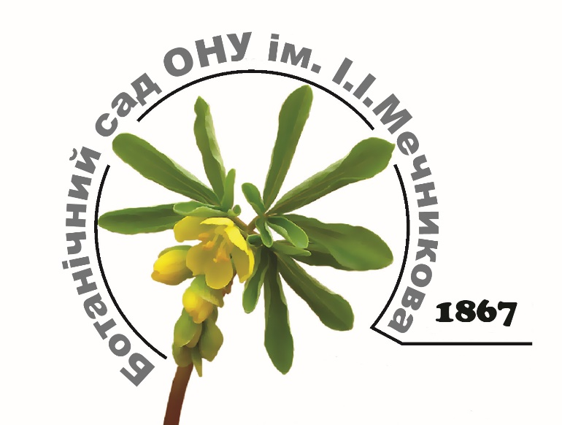

International scientific conference
"THE GENE POOL OF THE COLLECTIONS OF BOTANICAL GARDENS AND ARBORETUMS - THE KEY TO SUSTAINABLE PHYTOCENOSIS IN THE CONTEXT OF CLIMATE CHANGE"
dedicated to the 150th anniversary of the V. I. Lipsky Botanical garden
of Odesa I. I. Mechnikov National University

Odesa, 19-21 September, 2017

The first information letter

DEAR COLLEAGUES!
We would like to invite you to participate in the international scientific conference "Gene pool of the collections of botanical gardens and arboretums – the key to sustainable phytocenosis in the context of climate change" dedicated to the 150th anniversary of the V. I. Lipsky botanical garden of the Odesa I. I. Mechnikov National University. The conference will be held on 19-21 September, 2017 on the basis of the Botanical garden of the Odesa I. I. Mechnikov National University.
THE THEMATIC DIRECTIONS OF THE CONFERENCE:
1. Problems of preservation and enrichment of biodiversity of collections of Botanical gardens and arboretums in the context of climate change;
2. Plant introduction in the modern world: theoretical and practical aspects;
3. The problem of bioinvasions. Plant protection;
4. The contemporary practice of landscape gardening, landscape design and phytodesign;
5. Educational and social role of botanical gardens and arboretums.
The conference work is planned in two sections:
I. The collections of open ground;
II. The collections of greenhouses.

Conference languages: Ukrainian, English, Russian.

FORMS OF PARTICIPATION:
1. The report at the plenary session;
2. Report on sections;
3. Poster presentation;
4. Correspondence participation (only publication).

IMPORTANT DATES:
15th July 2017 – mailing the Second Information Letter containing the conference program, accommodation terms and costs, meals and excursions.
1st September 2017 – deadline for submission of papers to be published in the Conference Proceedings and of documents confirming participation fee payment.

THE ORGANIZING COMMITTEE PLANS TO PUBLISH THE CONFERENCE MATERIALS AS A SEPARATE COLLECTION

REGISTRATION AND REQUIREMENTS FOR PAPER FORMAT

A completed Registration Form and article (a *.doc/*docx file as well as *.pdf file with signatures of publication authors on the last page) are to be sent to the Organizing Committee at 150-gardenonu@ukr.net.
Please name your Registration Form and article after the surname of the first author in Latin characters, e.g.:
Slyusarenko-reg.doc; Slyusarenko-st.doc.
All applicants will be notified by the Organizing Committee of the state of the application proceeding.
The Organizing Committee reserves the right to reject papers containing many errors, as well as those failing to meet the requirements and stated conference topics.
In case of being admitted, participants are to pay the participation fee and email a scanned JPEG copy of the payment receipt to the Organizing Committee. If the Organizing Committee does not confirm receiving your payment confirmation, email within 3 workdays, please resubmit the required papers or call the Conference Secretary. Authors of papers bear responsibility for reliability of data provided in their articles.

MANUSCRIPTS FORMAT
Papers accepted for publication are not to exceed 3 size A4 papers in Microsoft Word format (*.doc / *.docx), typed in Times New Roman fonts, size: 14 pt, line spacing: 1. Margins: 2,5 cm along the perimeter, paragraph spacing: 1,25 cm. Text should not contain word breaks. Pictures: black-and-white in *.jpg format; diagrams: black-and-white, created in Microsoft Excel. Genus and species names of taxons in Latin are to be written in italics (e.g. Robinia pseudoacacia L.). When you link to the source literature you should indicate it in the text in parentheses (author, year).

Structure of presentation:
UDC (on the left, in semi-bold)
The title of the report
Slusarenko O. M. ¹, Vasylyeva T. V. ²
¹The title of organization, city, country, e-mail of the contact person
² The title of organization, city, country, e-mail of the contact person
Summary. The text up to 10 lines.
Summary. Slyusarenko O. M., Vasylyeva T. V. Title of materials. Text of Summary up to 10 lines.
The text of the article
text.... (Slyusarenko, 2015)
Table 1. The title of the table
The text of the article.

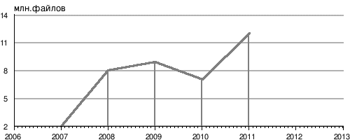
Fig. 1. The name of the figure and the graphical symbols
The text of the article.
Bibliography
- Slusarenko O. M. The title of the article. Journal, year, volume, page number.

CONFERENCE PARTICIPATION FEE
Participants attending in person – 150 UAH (to cover expenditures related to preparation of conference materials, information and organizational support, coffee breaks etc.). Transportation, hotel accommodation and catering expenditures are covered by the conference participants themselves. A fee for botanic tea will be paid by participants during the registration.
Participants attending in absentia (publication of materials) – 100 UAH. (in order to cover expenditures related to preparing and publishing the conference proceedings).
TRANSFER OF PARTICIPATION FEE:
The registration fee is to be sent by bank transfer to KR № 1257359800 at "Raiffeisen Bank Aval" in the name Vasylieva Tetiana Vladimirovna.
Be sure to include your name and the purpose of the transfer: "Payment for participation in the conference" and /or "Payment for the scientific article" on the form of payment. Foreign participants pay the registration fee according to the exchange rate on the date of transaction.
CONTACT INFORMATION
E-mail address | 150-gardenonu@ukr.net
The details for the money transfer | recipient: Vasylieva Tetiana  identification code: 2268122905  beneficiary's account: № 26251167901  Beneficiary Bank: AT "Raiffeisen Bank Aval"  Bank code (MFO)323851  Purpose of payment: Replenishment of KR № 1257359800  Specify the sender of the payment
Mailing address | Botanical garden of ONU  Frantsuzsky Boulevard, 48/50,  Odesa, 65058, Ukraine
Phone | + 38 (048) 746-57-19 tel./Fax;  +38 (050) 390-50-02 - Vasylieva Tetiana Vladimirovna − the Secretary of the Conference Organizing Committee

Information about the conference is available on the University website ("Conferences" section): http://onu.edu.ua/uk/science/botanicgarden

The second information letter and the conference program will be sent after July 15, 2017. It will provide information about the conditions and cost of accommodation, meals and excursions.

The Organizing Committee will be grateful if you kindly spread the news about the conference among all your colleagues who would like to participate in our conference.
APPLICATION
to participate in the international conference
"Gene pool of the collections of botanical gardens and arboretums – the key to sustainable phytocenosis in the context of climate change"
1. Country
2. The name of the institution (organization)
3. Surname
4. Name
5. Patronymic
6. Position
7. Degree
8. Title
9. Topic of report
10. Direction name
11. Form of participation (presentation, poster presentation, part-time participation)
12. Business Address
13. e-mail, phone
14. The need for a written invitation to the conference
15. Need for hotels

